Game Classes Hierarchy

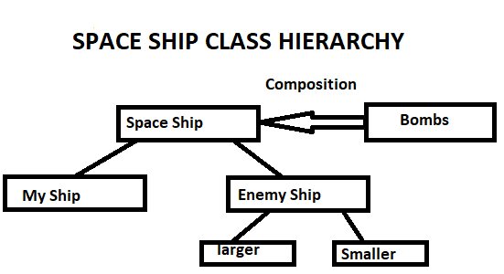

In spaceship class, Bombs Class is composed by doing this both child classes My Ship and Enemy Ship use Bombs. Now Enemy class have two childes one is larger and other is smaller both have different attributes.

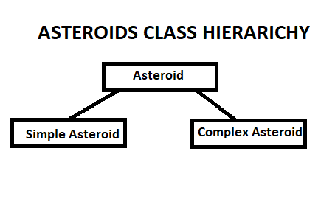

Asteroid class have two childes one is simple other is complex. Asteroid class contains function like draw,destroy etc.

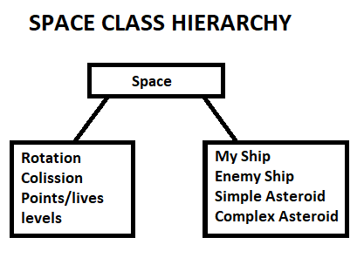

Space class is my main class which composed of My ship, Enemy ship, Simple Asteroid, Complex Asteroid classes and also some main functions like rotation of objects, Collision of objects, Score, lives and level of game